To the parents/guardians of:

AVERY 5160 LABEL HERE

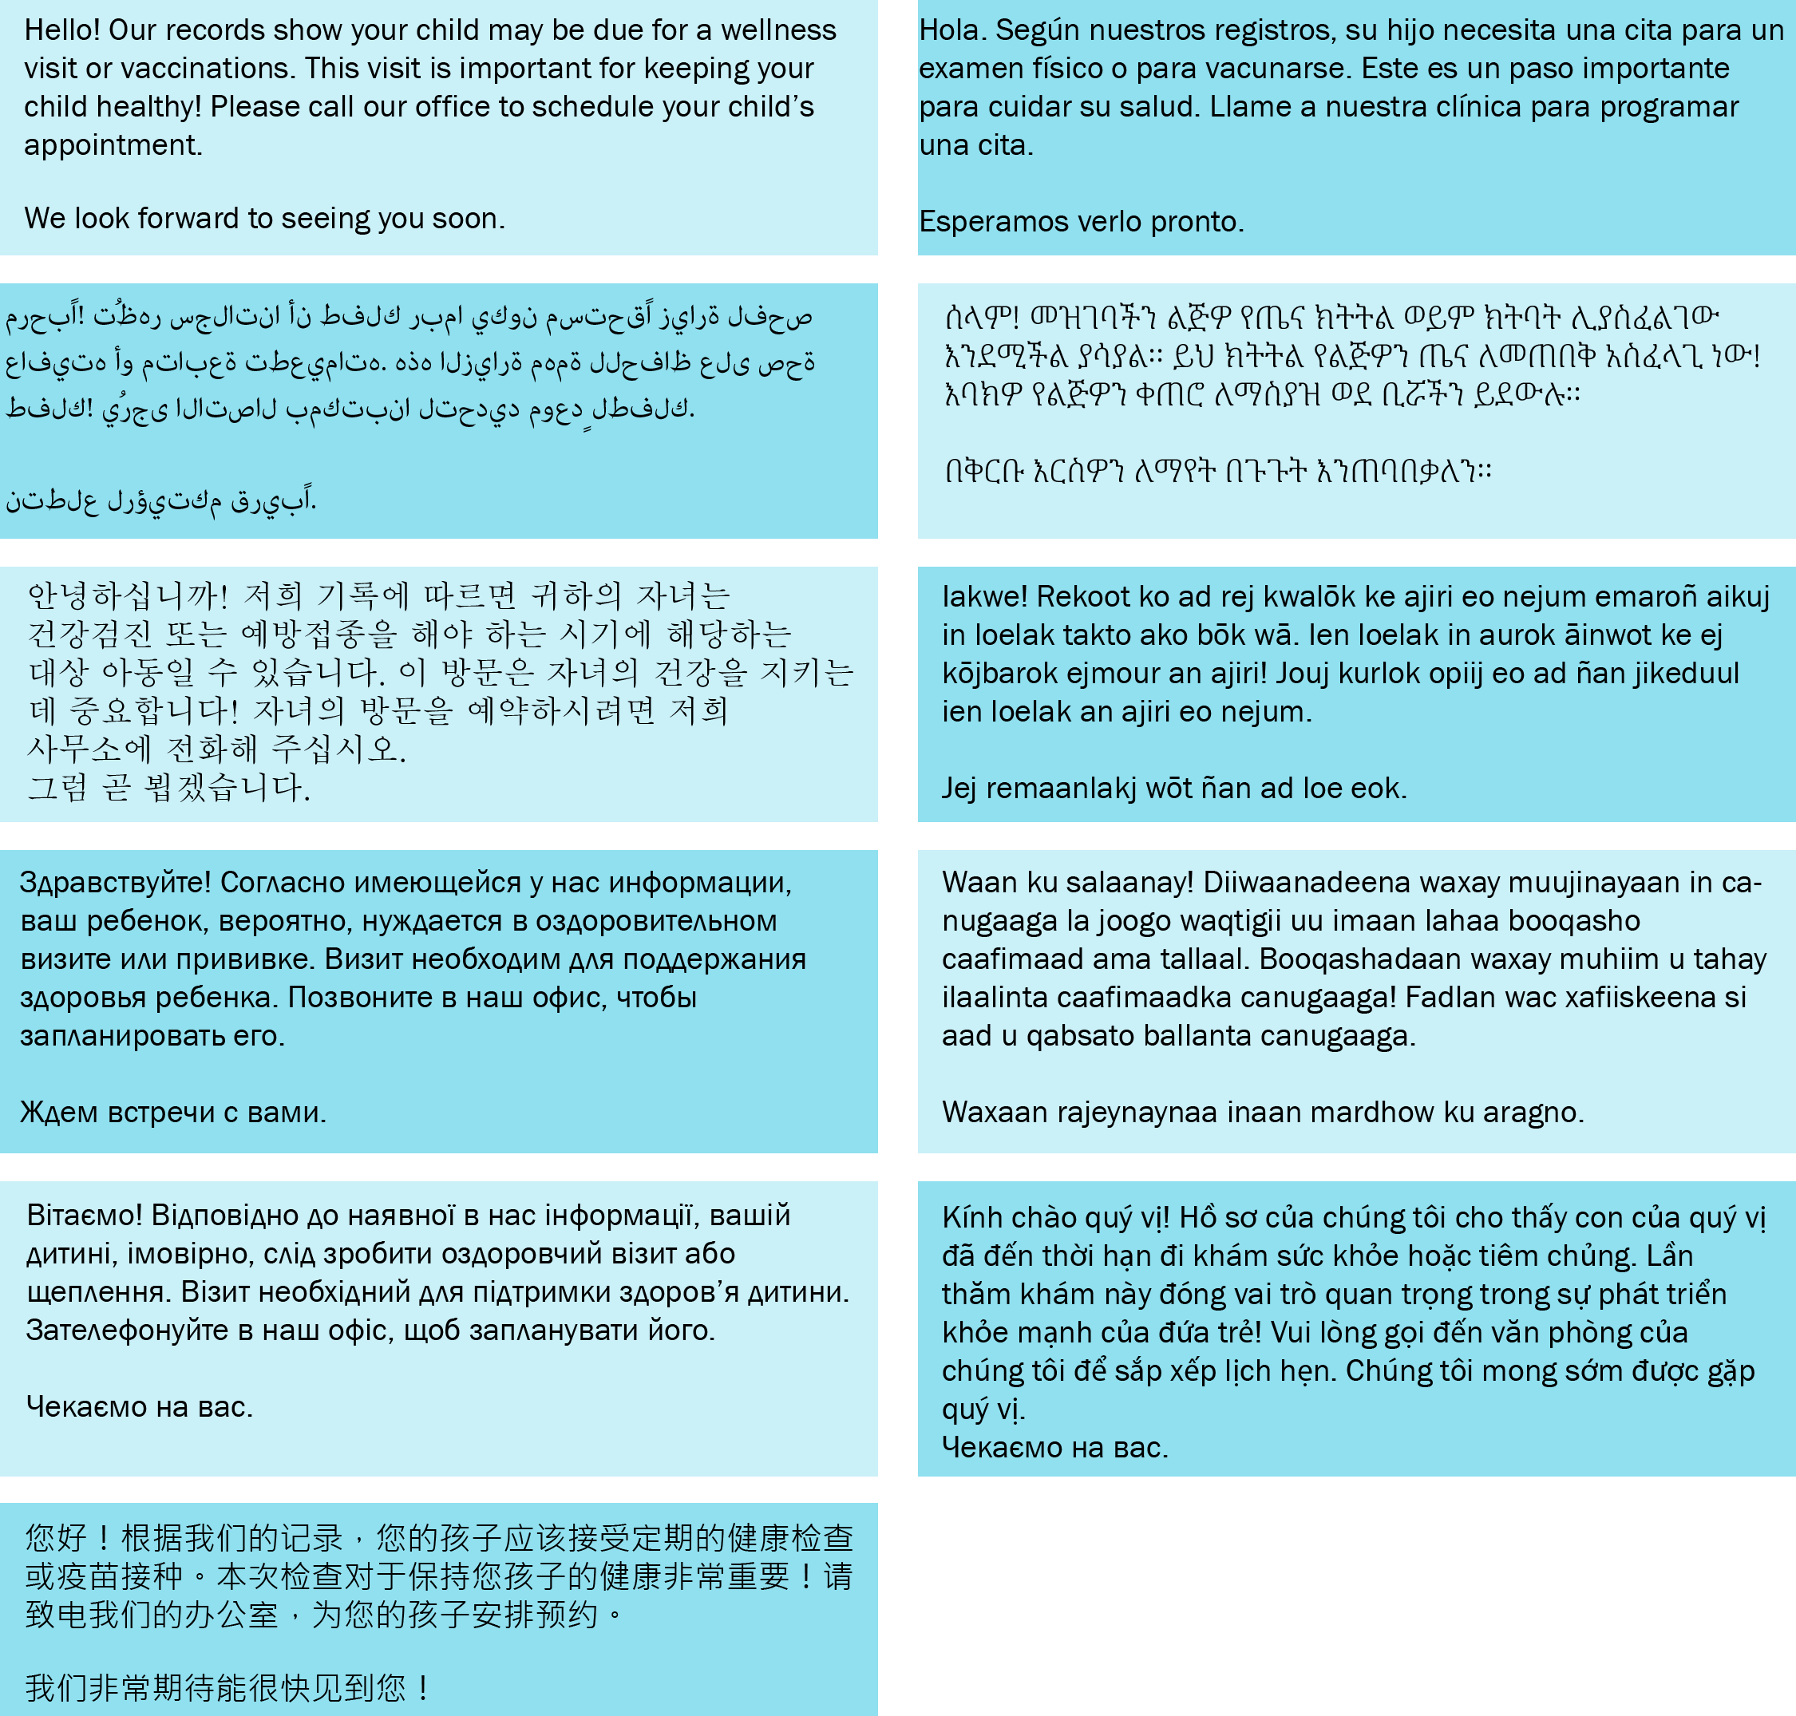

**VIETNAMESE**

**MARSHALLESE**

**UKRAINIAN**

**SOMALI**

**SIMPLIFIED CHINESE**

**RUSSIAN**

**KOREAN**

**ARABIC**

**AMHARIC**

**SPANISH**

**ENGLISH**

|  |  |
| --- | --- |
| A picture containing rectangle, square, screenshot, design  Description automatically generated OLY CLINIC (111) 111-1111 | To request this document in another format, call 1-800-525-0127. Deaf or hard of hearing customers, please call 711 (Washington Relay) or email [doh.information@doh.wa.gov](mailto:doh.information@doh.wa.gov). March **2025 DOH 348-964** |