(DATE)

Dear Provider,

Many school districts are returning to some level of face-to-face instruction, and outdoor school sports are resuming across the state. Students are required to be up-to-date on immunizations to attend in-person instruction and athletics.

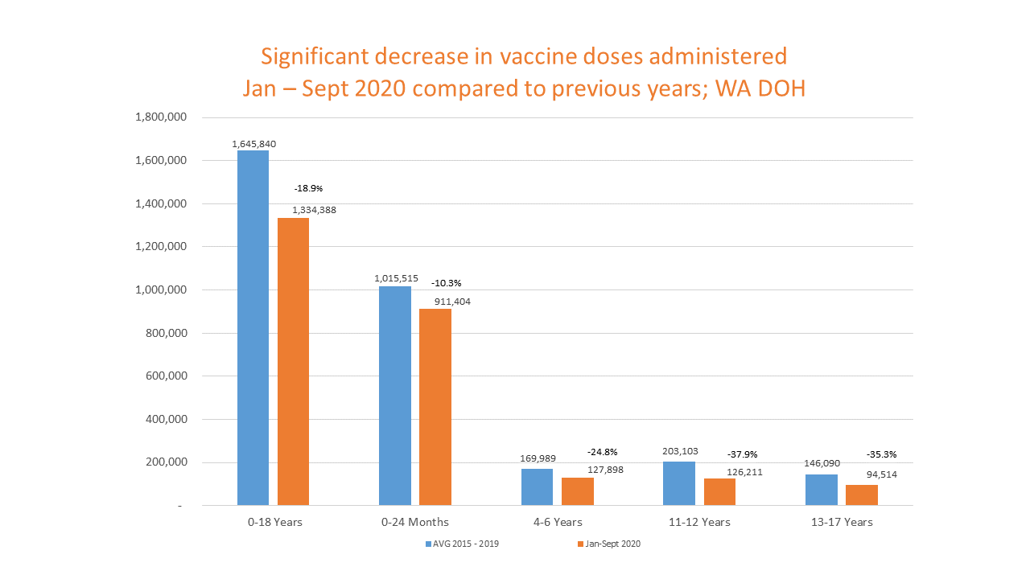
The Advisory Committee on Immunization Practices (ACIP) has issued guidance on the importance of continuing to immunize during the COVID-19 pandemic. Childhood and adolescent immunization rates in Washington are the lowest they have been in a decade. Our adolescent vaccinations have been most impacted.

The time to act is now. As we await COVID-19 vaccinations for children and adolescents, we need to make sure we are protecting kids from other diseases by getting them caught up on vaccines required for in-person instruction. Take advantage of this winter and early spring to bring your pediatric patients up to date on routine vaccinations.

Consider taking the following actions:
- Use your EMR patient portal, email, phone calls or texts to target outreach. Contact patients due for well-child visits associated with shots (0-2, 4-5, 9-11 and 16-18 years).
- Send reminder/recall letters. Include information about COVID-19 safety measures your clinic is taking.
- Run your clinic’s coverage rates in the WA-IIS.
- Include information on your website and in social media about the importance of routine immunizations during the COVID-19 pandemic.
- Offer telehealth and nurse-only quick shot visits.
- Consider hosting drive-thru or pop-up vaccine clinics on site. Consider weekend vaccine clinics to help busy families.
- If available in your region, partner with school-based health centers to expand immunization options.
- Educate patients who recently lost insurance about Medicaid options and no-cost vaccines.
- Encourage patients to use MyIR to check their immunization status.

Please consider acting on these suggestions immediately. Your strong recommendations for immunizations are critical to protecting our community against an outbreak of vaccine preventable disease during the pandemic, especially as we return to in-person instruction.

Sincerely,

Resources
- WA State Department of Health School & Child Care Immunization: www.doh.wa.gov/SCCI
- Pediatricians discuss ways to prepare ahead of COVID-19 vaccination of children AAP news December 21, 2020
- Interim Guidance for Immunization Services During the COVID-19 Pandemic CDC website
- CDC webinars COVID-19 CDC website
- COVID-19 Vaccine Safety webinar WA DOH website
- myIR family access to immunization records
- Reminder/Recall and Running coverage rates WA DOH website
- WA Apple Health - Medicaid
- ParentHelp123
- See attached sample patient recall letter

