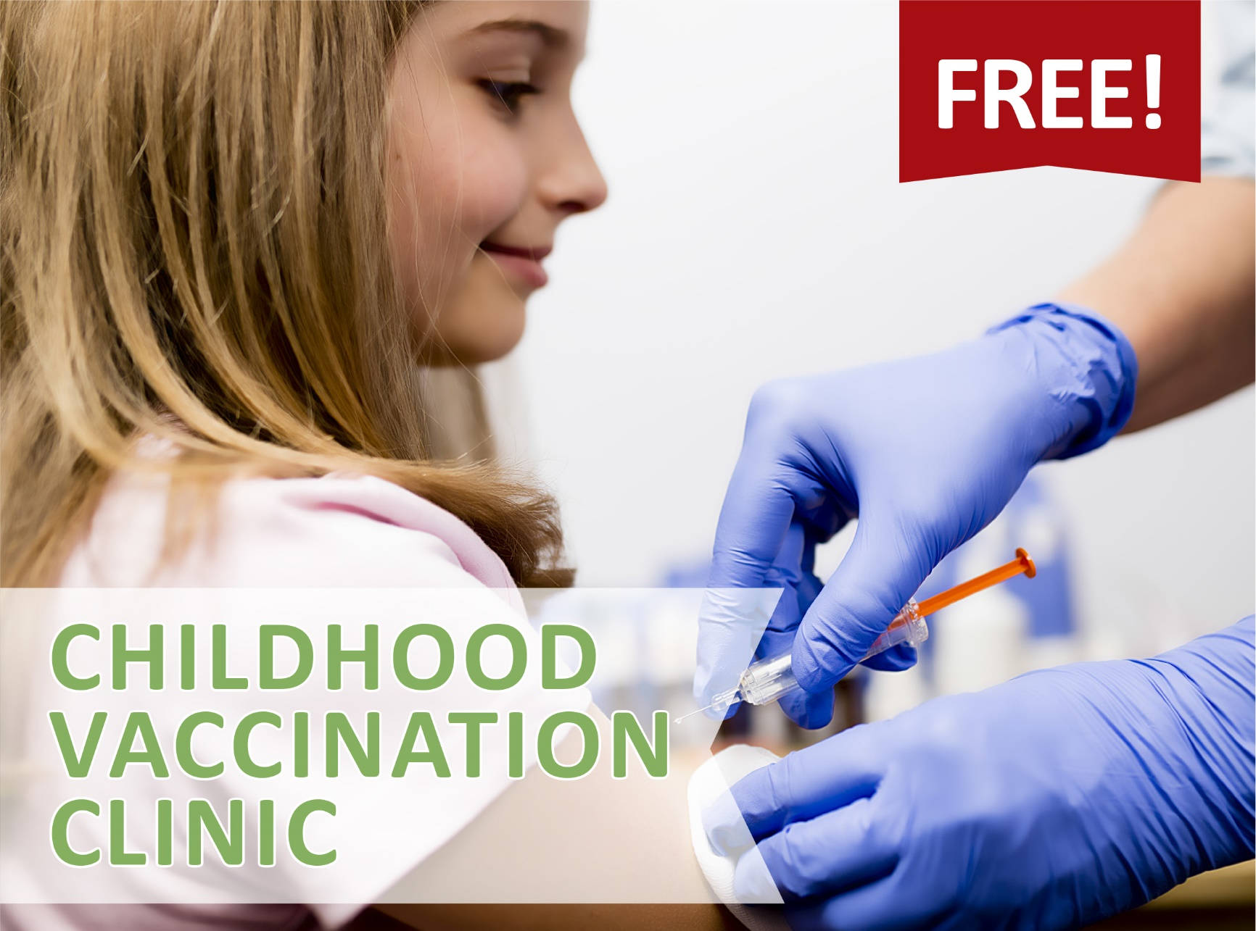

August 24, 2015 • 3 p.m. – 7 p.m.
There will be a limited supply of adult vaccine available.
Reardan Elementary School
East 215 Spokane Avenue
Reardan, WA 99029

QUESTIONS? Contact Larae Peterson, RN, (509) 796-2701 ext 317

In partnership with:

