In partnership with:
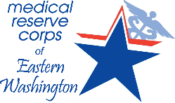

FALL 2016

Reardan Elementary*
Wednesday, September 21, 1 p.m. - 5 p.m. E. 215 Spokane Ave.

Shaw Middle School*
Friday, September 30, 2 p.m. -6 p.m. 4106 N. Cook St.

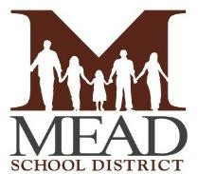
Farwell Elementary*
Tuesday, October 4, 3:30 p.m. - 6 p.m. 13005 N. Crestline

Sunset Elementary*
Wednesday, October 19, 3 p.m. - 6 p.m. 12824 W. 12th St.

Questions? Please call Alexandra Hayes at 509-324-1480

